**QUESTION 1 TEST CASE RESULTS (VS Code Terminal)**

**BackPainAnalyzer.java**

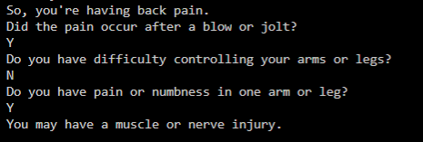

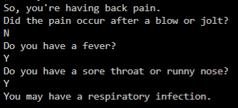

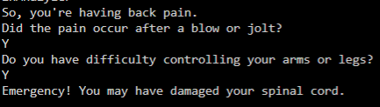

**Covid19Analyzer.java**

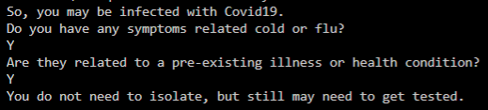

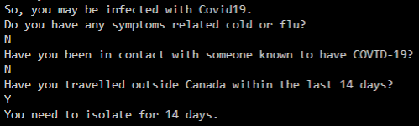

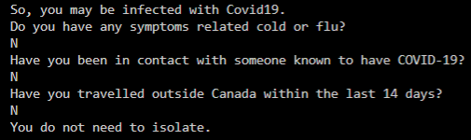

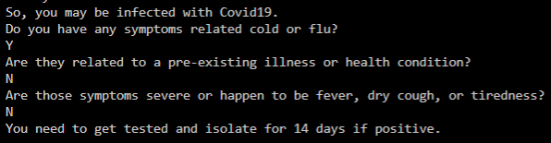

**QUESTION 2 TEST CASE RESULTS**

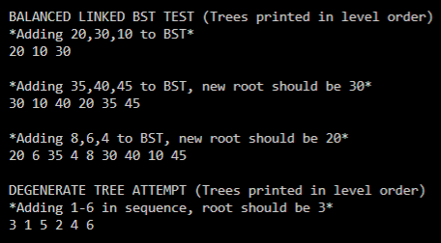

The level order shows the root of the tree and which elements are at each level. The tree can then be drawn from the string as such for case 2 (adding 35, 40, 45), where the new root is 30**:**

30

10 40

20 35 45

The new root is 30, which indicates balancing every time a new element is added.

For case 4 (adding 1-6 in sequence), where a degenerate tree is attempted, the balanced tree is correct**:**

3

1 5

2 4 6